What is cloud computing?

Cloud computing is the delivery of computing services—such as servers, storage, databases, networking, software, and analytics—over the internet instead of using your own local computer or on-site servers.
Simple Example
Instead of storing files only on your laptop:
- You upload them to a cloud service like Google Drive or Microsoft OneDrive.
- The files are stored on remote servers and can be accessed from anywhere with an internet connection.



Key Characteristics
- On-demand access: Use resources whenever you need them.
- Scalability: Easily increase or decrease resources.
- Pay-as-you-go: Pay only for what you use.
- Accessibility: Access services from any device connected to the internet.
- Maintenance handled by providers: The cloud provider manages hardware and infrastructure.
Types of Cloud Services
- Infrastructure as a Service (IaaS)
  - Provides virtual servers, storage, and networking.
  - Example: virtual machines on Amazon Web Services.
- Platform as a Service (PaaS)
  - Provides a platform for developing and deploying applications.
  - Example: application hosting environments.
- Software as a Service (SaaS)
  - Delivers software through a web browser.
  - Examples: email, online office suites, and customer relationship management tools.
Benefits
- Lower upfront costs
- Faster deployment
- Easy collaboration
- Automatic updates and backups
- High availability and disaster recovery options
Everyday Examples
- Streaming movies on Netflix
- Storing photos in cloud storage
- Using web-based email services
- Running business applications online
In short, cloud computing means using computing resources over the internet instead of owning and maintaining the hardware yourself.

What are the advantages of using Microsoft Azure?

Scalability
- You can quickly increase or decrease computing resources based on your workload, making it suitable for both small applications and large enterprise systems.
Cost-Effective
- Azure follows a pay-as-you-go pricing model, so you pay only for the resources you actually use instead of investing heavily in physical infrastructure.


High Availability
- Azure offers data centers around the world, helping applications remain available and minimizing downtime through redundancy and disaster recovery features.
Strong Security
- It provides built-in security features such as encryption, identity management, firewalls, and threat detection to help protect applications and data.
Global Reach
- With data centers across many regions, users can deploy applications closer to their customers for lower latency and better performance.
Easy Integration
- Azure integrates well with products like Microsoft 365, Windows Server, and Visual Studio, making it convenient for organizations already using the Microsoft ecosystem.
Supports Multiple Programming Languages
- Developers can build applications using languages such as Python, Java, C#, JavaScript, PHP, and many others.
Backup and Disaster Recovery
- Azure provides cloud backup and recovery services that help organizations restore data quickly in case of failures or disasters.
AI and Machine Learning Services
- Azure includes ready-to-use services for artificial intelligence, machine learning, analytics, and data processing, allowing developers to build intelligent applications more easily.
Hybrid Cloud Capability
- Azure supports hybrid environments, allowing organizations to combine on-premises infrastructure with cloud resources for greater flexibility.

what is hosting in azure?

Hosting in Azure means deploying and running your applications, websites, databases, or services on Microsoft Azure's cloud infrastructure instead of on your own physical servers.

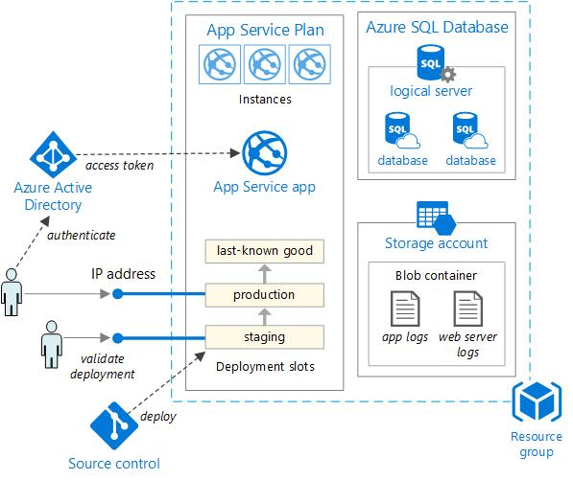

For example:
- If you create a website, instead of hosting it on your own computer, you can upload it to Azure.
- Azure provides the servers, storage, networking, and security needed to keep the website running 24/7.
- Users can access your application from anywhere over the internet.
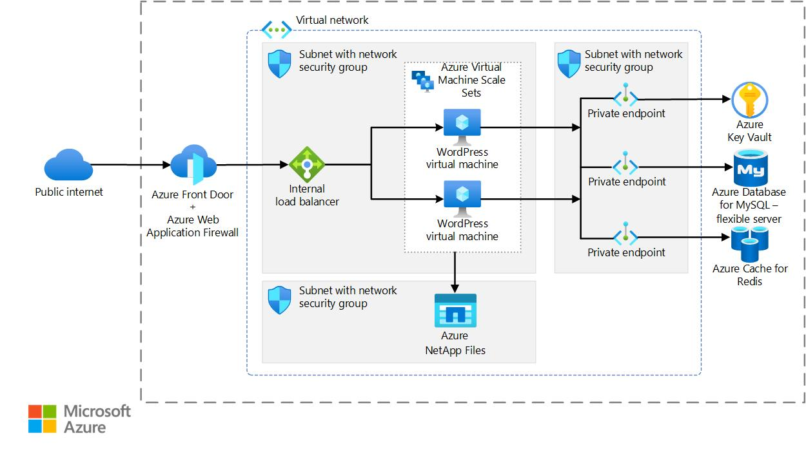

Common Azure Hosting Services
- Azure App Service
  - Used to host web applications and APIs.
  - Supports languages like Python, Java, .NET, Node.js, and PHP.
  - Azure handles server management automatically.
- Azure Virtual Machines
  - Lets you create virtual servers in the cloud.
  - You have full control over the operating system and installed software.
- Azure Kubernetes Service
  - Used for hosting containerized applications at scale using Kubernetes.
- Azure Functions
  - Hosts small pieces of code that run only when triggered, without managing servers.
Example
Suppose you develop an online shopping website:
- Without Azure hosting: You buy and maintain your own server, internet connection, power backup, and security.
- With Azure hosting: You deploy the website to Azure, and Microsoft manages the underlying infrastructure while you focus on your application.
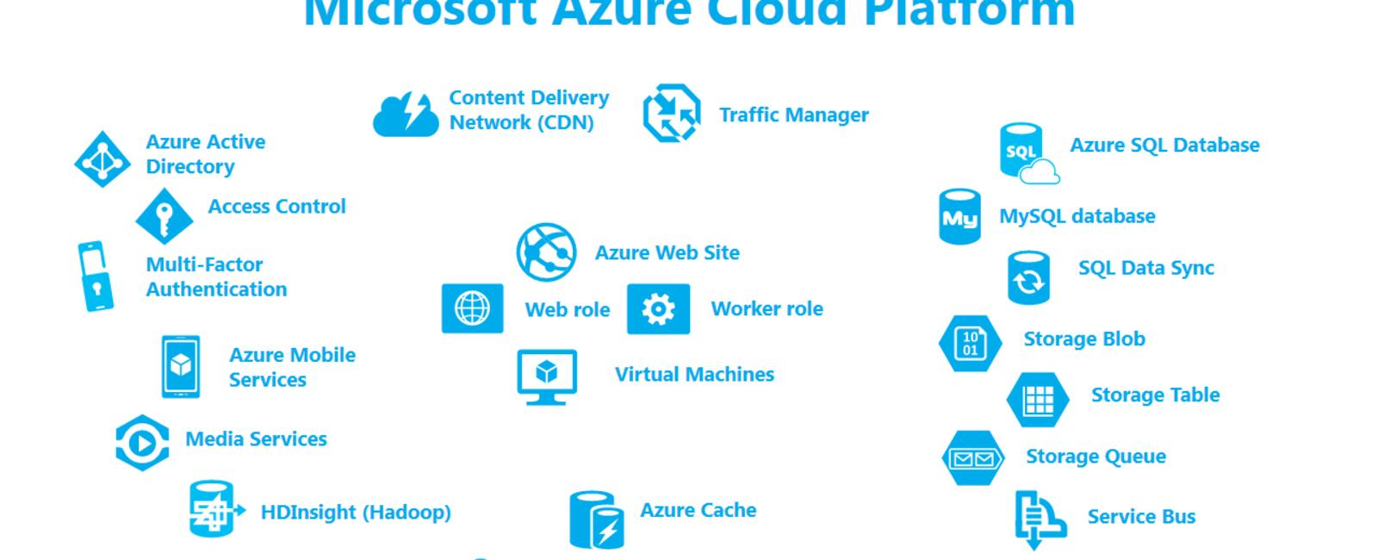

Benefits of Azure Hosting
- Accessible worldwide over the internet
- Easy to scale up or down based on traffic
- High availability and reliability
- Built-in security and monitoring
- Pay only for the resources you use

what is Iaas , Paas , Saas?

IaaS, PaaS, and SaaS are the three main cloud computing service models. They differ in how much of the infrastructure is managed by the cloud provider versus the customer.

Service Model | Full Form | What You Manage | What the Cloud Provider Manages
IaaS | Infrastructure as a Service | Applications, data, runtime, OS | Servers, storage, networking, virtualization
PaaS | Platform as a Service | Applications and data | Infrastructure, OS, runtime, middleware
SaaS | Software as a Service | Only use the software | Everything else
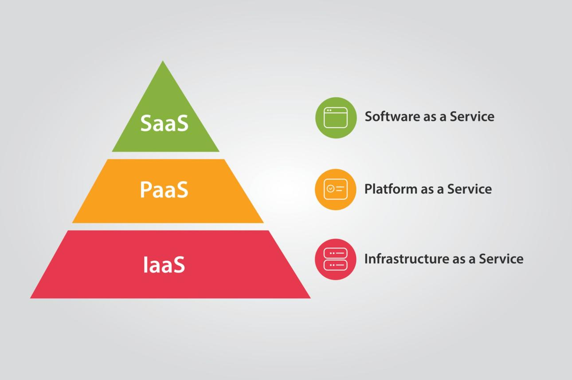

1. IaaS (Infrastructure as a Service)
IaaS provides virtual servers, storage, and networking over the internet.
- You install and manage the operating system and applications.
- Suitable for organizations that need maximum control.
Example services:
- Azure Virtual Machines
- Amazon EC2
Example: Renting an empty apartment—you bring your own furniture and arrange everything inside

2. PaaS (Platform as a Service)
PaaS provides a platform for building and deploying applications without managing servers or operating systems.
- Developers focus on writing code.
- The provider manages infrastructure and runtime.
Example services:
- Azure App Service
- Google App Engine
Example: Renting a fully furnished apartment—you only move in and live there.

SaaS (Software as a Service)
SaaS delivers ready-to-use software over the internet.
- No installation or server management is required.
- Users simply sign in and use the application.
Examples:
- Microsoft 365
- Gmail
- Salesforce
Example: Staying in a hotel—everything is provided, and you simply use the service.
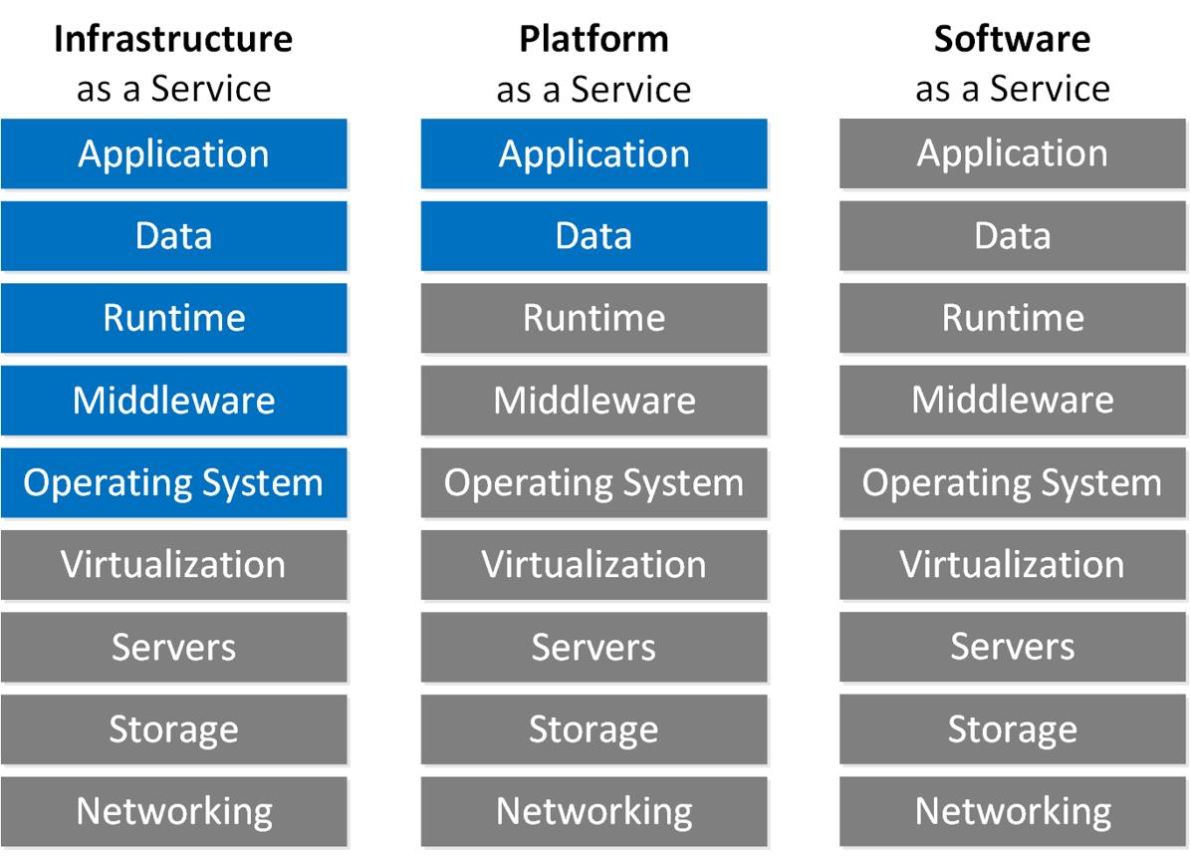

- IaaS = Rent Infrastructure (servers and networking)
- PaaS = Rent a Development Platform (build and deploy apps)
- SaaS = Use Ready-Made Software (just log in and use it)
Real-world analogy
- IaaS: Buy ingredients and cook yourself.
- PaaS: Get a meal kit with ingredients and kitchen provided.
- SaaS: Eat at a restaurant where everything is prepared for you.

